Number 034(T) of 2026 | 03/02/2026

MDL Dredging

NOTICE IS HEREBY GIVEN that Jenkins Marine will be engaged in dredging operations at Saxon Wharf and Ocean Village Marina.

Saxon Wharf dredging will commence on or around 30th January 2025 for approximately 2-3 weeks following that they will work out of Ocean Village for 3-4 weeks.

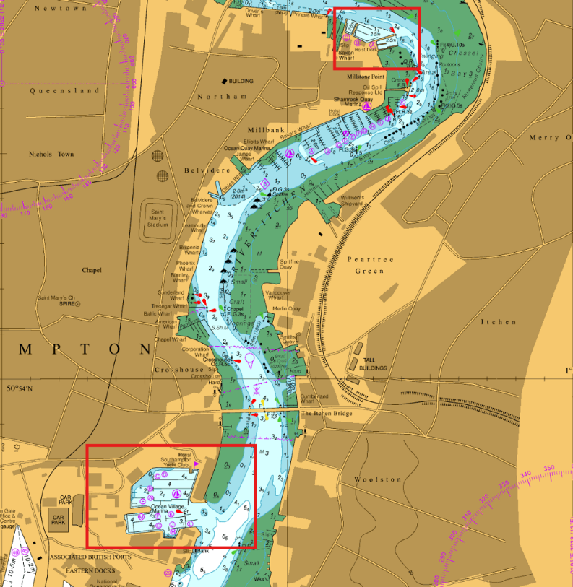

Vessels involved in dredging works are the Backhoe Dredger ’’DOREEN DORWARD’’ and Split hopper barges ‘’NAB’’ and “NEEDLES”

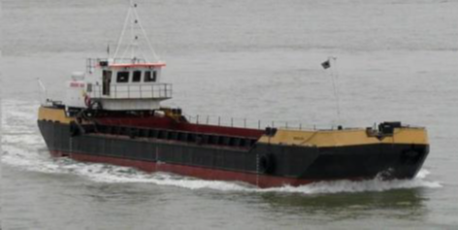

Vessels will display lights and shapes as required by the COLREGS and will maintain a listening watch on VHF Channel 12. Mariners are advised to remain outside of the works area, passing with slow speed and minimum wash. Additional information can be requested from “Southampton VTS” on Channel 12.

Weather permitting, these operations will be continuous throughout the stated period and mariners should expect to pass these vessels at any time between the upper reaches of Southampton Water and the Nab or Hurst Disposal Ground.

This notice will be self-canceling on completion.

Steven Masters,
Harbour Master

