Number 39(T) of 2026 | 26/02/2026

SG2 Boreholes

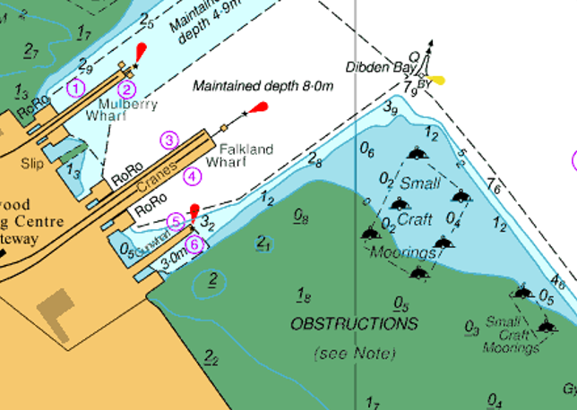
NOTICE IS HEREBY GIVEN that mariners are to be advised that the ‘Causeway Giant 1’ will be conducting borehole operations around Solent Gateway berths 3, 4, 5 and 6, as well as in the subtidal and intertidal mudflat areas as pictured in Figure 1, adjacent to the main navigable channel. Work is expected to start on 2nd March, and anticipated completion is expected by 15th May 2026, however may be extended. The ‘Causeway Giant 1’ will be moved into locations with ‘Ocean Supporter’ and crew will be transferred daily via the ‘Ocean Quest’. Operations will be ongoing 24 hours a day.
Figure 1: Red box highlights the area where borehole operations will be carried out by Causeway Giant 1 with Ocean Supporter.

Vessels will display lights and shapes as required by the COLREGS and will maintain a listening watch on VHF Channel 12. Mariners are advised to keep clear as safe navigation permits, passing with slow speed and minimum wash. Additional information can be requested from “Southampton VTS” on Channel 12.

This notice will be self-canceling on completion.

Steven Masters,
Harbour Master

