Number 03 of 2026 | 01/01/2026

Use of dangerously weighted heaving lines & line throwing devices

NOTICE IS HEREBY GIVEN that crews of vessels using the Port of Southampton are required to use properly constructed heaving lines for all mooring and towing operations. The use of ‘dangerously weighted' heaving lines is both illegal and dangerous and may cause serious injury or even death to those on the receiving end ashore or onboard a tug or mooring boat.

Ships’ agents are requested to bring this notice to the attention of Masters of all vessels calling at the Port.

The Code of Safe Working Practices for Merchant Seamen (2019), Chapter 26 (26.3.5) states:

To prevent personal injury to those receiving heaving lines, the ‘monkey’s fist’ should be made with rope only and must not contain added weighting material. Safe alternatives include a small high-visibility soft pouch, filled with fast-draining pea shingle or similar, with a weight of not more than 0.5 kg. Under no circumstances is a line to be weighted by items such as shackles, bolts or nuts, or twist locks.
Additionally, vessels’ mooring parties should always alert shore mooring gangs, tug crews or others in the vicinity prior to throwing a heaving line.

Heaving lines with dangerous weighting, such as pieces of metal, are not to be used under any circumstances and, if used, appropriate enforcement action will be taken including:

- The weight will be removed immediately and confiscated;
- The weight will be replaced with a suitable replacement;
- Should an external service provider confiscate a weighted leaving line this evidence must be transferred to the Berthing Officer.
- The Master will be issued with a notice explaining why action has been taken and issued with a charge of £1000.

Attached to this notice is an MCA Safety Bulletin (Figure 1) relating to Dangerously Weighted Ship’s Heaving Lines.

The use of any form of pneumatic, mechanical or rocket propelled line throwing device, such as that pictured (Figure 2), for the passing of heaving lines or any other non-emergency application is strictly prohibited at all berths, terminals and with tugs in the Port of Southampton unless in a case of emergency (and then only when agreed with all parties involved).

Steven Masters,
Harbour Master
MSF 5029 Rev 10/14

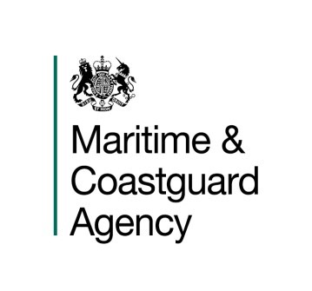

S
A
F
E
T
Y

B
U
L
L
E
T
I
N

N
o
.

2

DANGEROUSLY WEIGHTED
SHIPS HEAVING LINES

There have been several instances where dangerously weighted heaving lines, including the use of monkey’s fists with additional weights inserted into them, have been used resulting in serious injury.
Further guidance is contained in Ch 26 section 26.3.5 in the 2015 edition of the Code of Safe Working Practices for Merchant Seafarers.

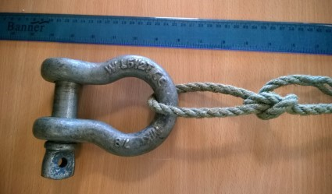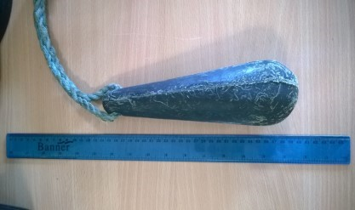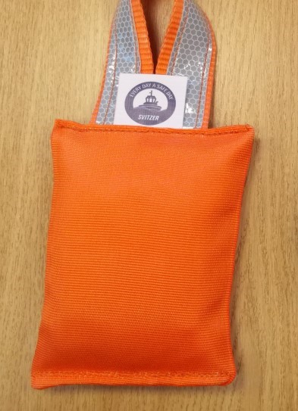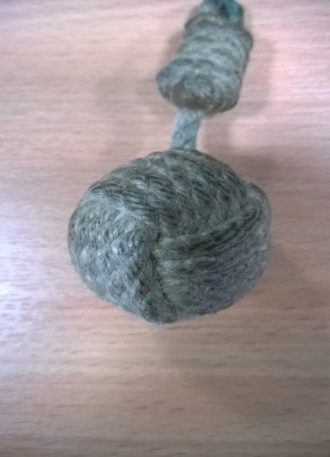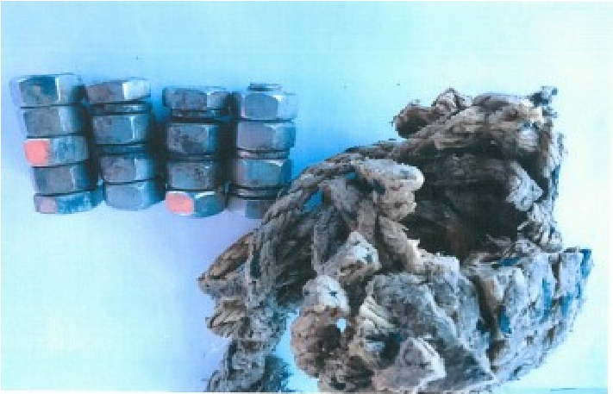
×

✓

×

×

×

✓

Figure 1 - MCA Notice, Dangerously Weighted Heaving Lines

Vessels using dangerously weighted heaving lines in the UK may be subject to
prosecution
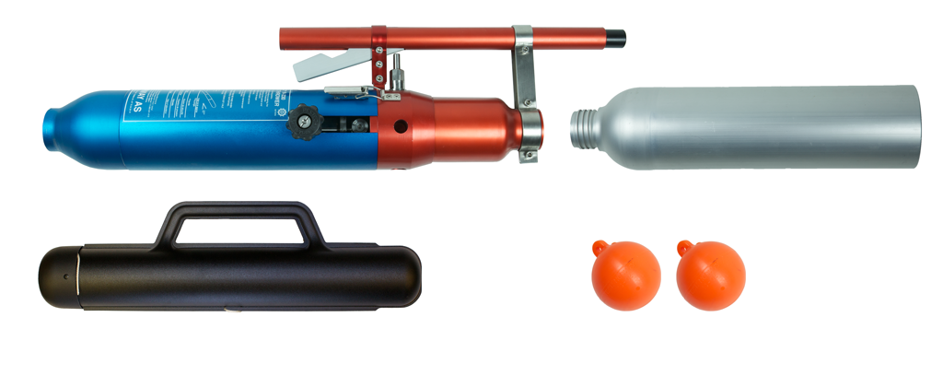
Figure 2 - Pneumatic Line throwing Device

