Number 018 of 2026 | 01/01/2026

Port of Southampton Designated Watersports Areas

NOTICE IS HEREBY GIVEN that the Port of Southampton is a busy and well-established commercial port that is heavily used by a variety of leisure craft. To try and deconflict commercial and leisure activities there are certain Watersports Zones that have been established. It is important that all users are aware of the appropriate areas to operate within, and the rules which apply to their use. These area’s do not take away the responsibility of vessel operators to always operate safely and with due regard to all other water users from swimmers to commercial ships.

Speed Limits

As per the Southampton Byelaws

- There is a speed limit of 6 knots which applies to all craft proceeding north of the imaginary line drawn from Hythe Pier to Weston Shelf Buoy as can be seen in Figure 1 below.

- No person shall operate a personal watercraft at a speed greater than 6 knots over the ground within 200 metres of Mean High Water Springs on either side of Southampton Water in the area hatched black on the map annexed to these Byelaws. (Map shown below)

- Outside of the above two areas, a 40 knot speed limit applies within Southamptons SHA

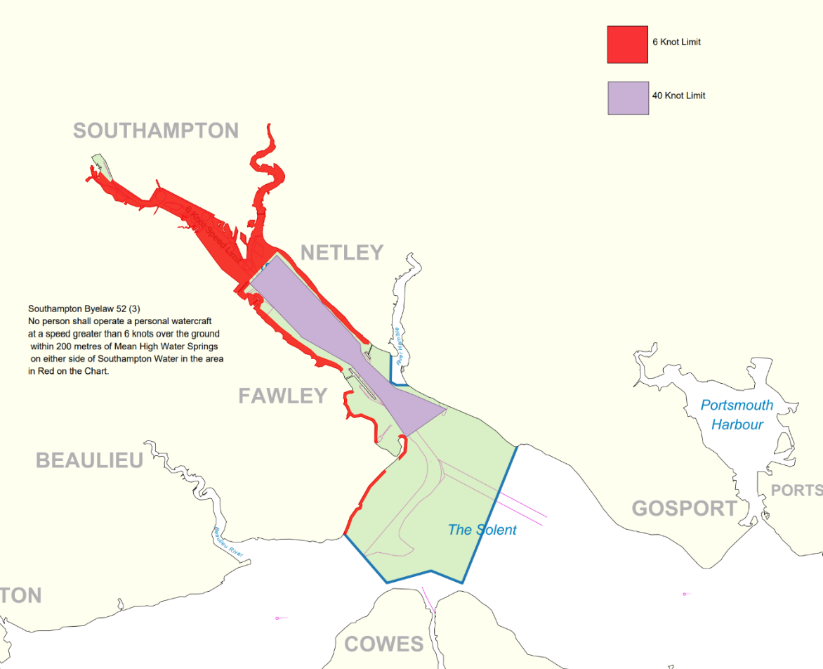
Figure 1 Southampton Speed Limits
All vessels / personal watercraft must pass the oil jetties at Fawley and Hamble no closer than 130m from the face of the jetties unless pertmission is granted by the Harbour Master.

The following information sets out different areas that are provided within the Port Limits for the use of various watersports activities:

Calshot Watersports Area

The area bound by the Calshot Spit and the Fawley Power Station channel and as marked by yellow special marks, is designated as a Watersports area, see Figure 2 below. This area provides a safe area for dinghy and dayboat sailing, windsurfing, kitesurfing and paddle sports. Please note kitesurfing in this area is NOT permitted between 1st April to 31st October as per General Direction 05.

Authorised support and rescue craft involved in support of these activities can also operate within this area. Within the area, all other powered craft not providing safety cover must adhere to the 6-knot speed limit. The Calshot Watersports area must not be used for activities involving the towing of persons.

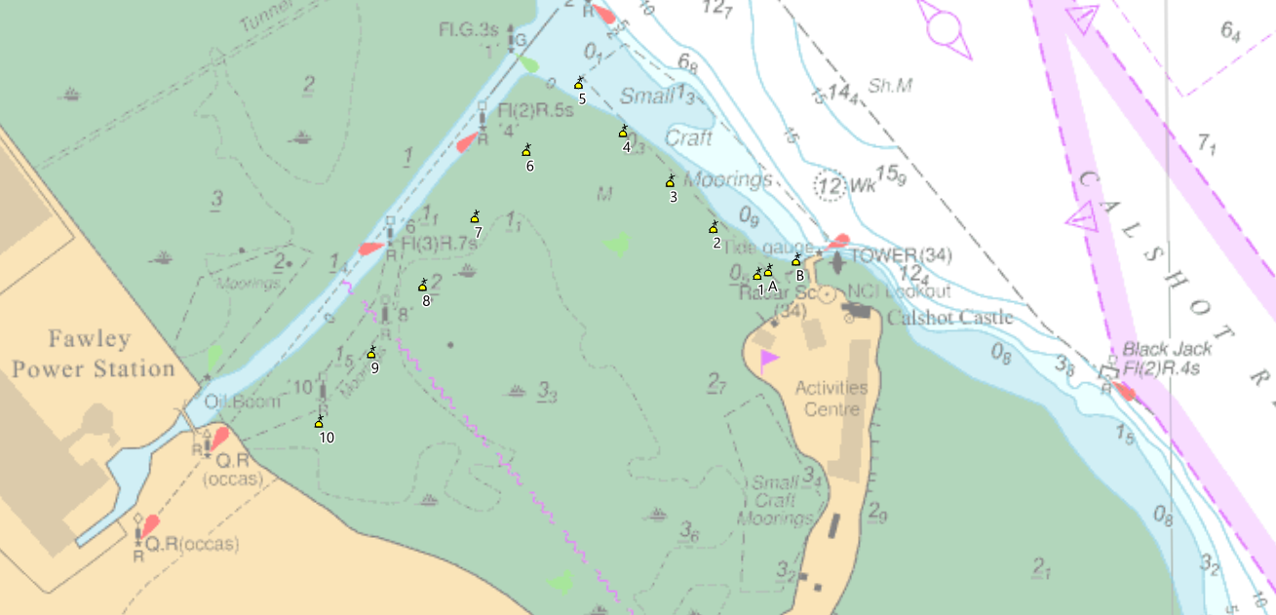

Figure 2 Calshot Water Sports Area

Calshot ‘Safe Swimming Area’

The New Forest District Council manages a swimming area off Calshot Beach at the Northern part of Stanswood Bay which is also known as a bathing area on the Admiralty Charts.

The swimming area is 200 metres wide and approximately 800m long and is surrounded by yellow cone shaped buoys. These buoys may be removed over winter for maintenance. The swim area is divided by a corridor to enable personal watercraft / jet skis etc to get from the shore to deeper water.

No power or sail driven craft are permitted to operate within the buoyed safe swimming area.

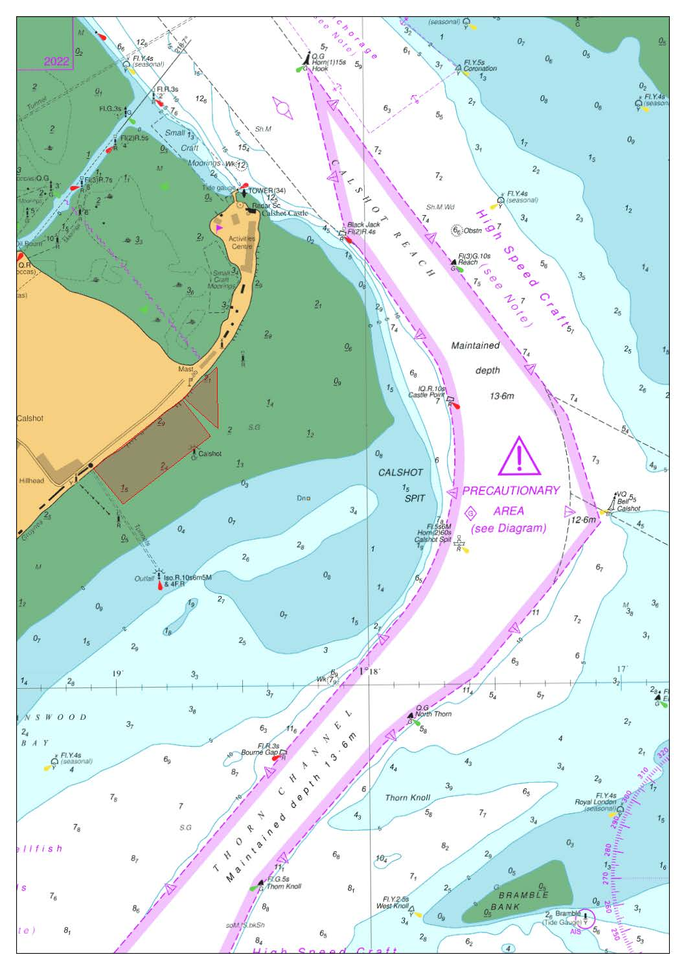
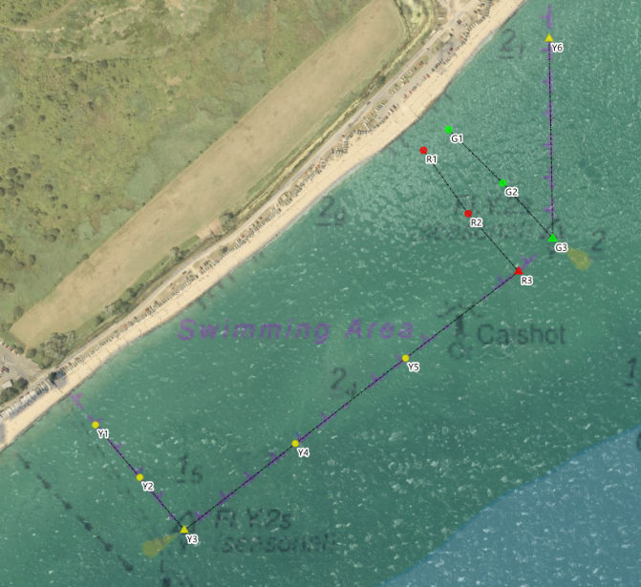

Southampton Byelaws – Water skiing, aquaplaning, power boat racing, paragliding etc

No person shall engage or take part in water skiing, aquaplaning, paragliding, power boat racing, parachute towing or any similar activity, except with the written permission of the Harbour Master given either specifically or generally and only in such areas as may be designated by the Harbour Master and in accordance with such reasonable

The Southampton Harbour Byelaws 2003 and the 2025 General Directions stipulate the legal rules that must be followed within the Port limits. Be advised that breaches in the Harbour Byelaws and General Directions may result in prosecution or enforcement actions. The ABP Southampton Statutory Harbour Area to which these legal rules apply is shown below (represented by the blue area).

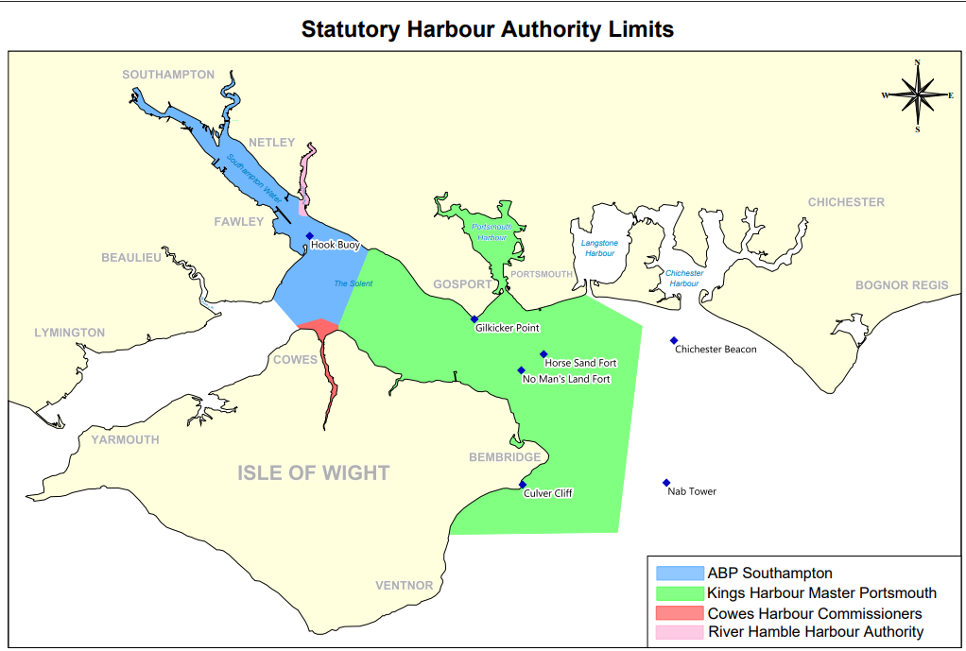
Eling Waterski Area

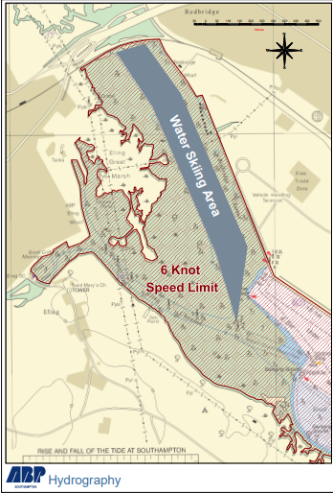

Waterskiing is only permitted within the Port Limits in the designated area shown above.

The waterski area at Eling is useable from approximately 1 hour before, until 2 hours after the 1st high water. There are some obstructions in the area, many of which are partially submerged, therefore large-scale admiralty charts should be consulted before use. The area extends from Totton Bypass bridge to Horse Head Buoy at the end of Southampton Container Terminal. The channels and areas surrounding this charted area are not permitted for waterskiing.

For the avoidance of doubt, personal watercraft/ jet skis, ribs, and other power craft (not involved in water skiing) must comply with the 6-knot speed limit throughout this entire area.

Steven Masters,
Harbour Master

