Number 05 of 2026 | 01/01/2026

Precautionary Area (Thorn Channel)

- NOTICE IS HEREBY GIVEN that all vessels navigating within the Port of Southampton shall ensure that a vessel greater than 220 metres in length overall shall be given a ‘clear channel’ in the area between the Hook Buoy and the Prince Consort Buoy (hereinafter referred to as ‘The Precautionary Area’ (Figure 1).

The term ‘clear channel’ is defined as:
‘a clear and unimpeded passage ahead of a vessel when transiting the Precautionary Area’.

The term ‘clear channel vessel’ is defined as:
‘a vessel greater than 220 metres in length overall which requires a clear and unimpeded passage ahead when transiting the Precautionary Area’.

Vessels may enter ‘The Precautionary Area’ maintaining a safe distance astern of a ‘clear channel vessel’.

- Two vessels each having a length greater than 180 metres length overall shall not pass or overtake each other between Hook Buoy and a line drawn due south of West Bramble Buoy.

- Moving Prohibited Zone (MPZ) (Figure 1)

Southampton Harbour Byelaws 2003 Byelaw No 11 enforces the requirement that all vessels over 150 metres in length overall when navigating within ‘The Precautionary Area’ referred to in this notice are automatically allocated a ‘Moving Prohibited Zone’ (MPZ). The MPZ is defined as an area extending 1000 metres ahead of the bow and 100 metres from the ship’s side on both sides of any vessel of over 150 metres in length overall whilst it is navigating within ‘The Precautionary Area’ (Figure 1).

The master of a small vessel (defined in Southampton Harbour Byelaws 2003 Byelaw No 3 as any vessel of less than 20 metres in length or a sailing vessel) shall ensure that the vessel does not enter an MPZ.

For the purpose of indicating the presence of the MPZ the master of any vessel of over 150 metres length overall shall display on the vessel, where it can best be seen, by day, a black cylinder, and by night, 3 all round red lights in a vertical line.
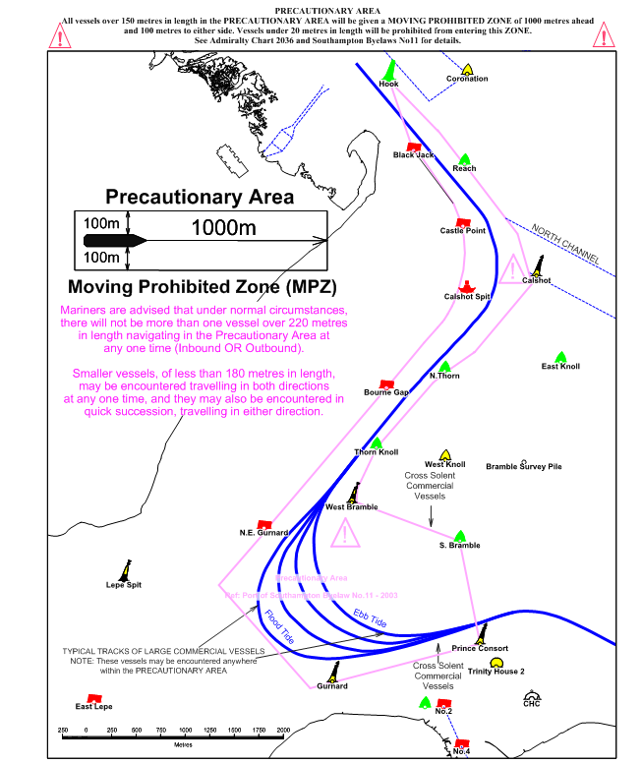
Figure 1 - Precautionary Area and Moving Prohibited Zone
- Tracks followed by Large Vessels

Masters of small vessels are advised that the tracks followed by large vessels within The Precautionary Area will vary considerably depending on the tidal and wind conditions prevailing at the time and the maneuvering characteristics of the vessels themselves. Figures 2 to 4 below demonstrate likely tracks for both inbound and outbound vessels in flood and ebb tide conditions.

The tracks and courses shown are indicative only and inbound and outbound vessels may use the full extent of The Precautionary Area. Unless prevented by emergency circumstance, Masters of small vessels should give all large vessels in The Precautionary Area a wide berth and, in particular, they should ensure that they do not enter a vessel’s MPZ.

- Inbound vessel tracks

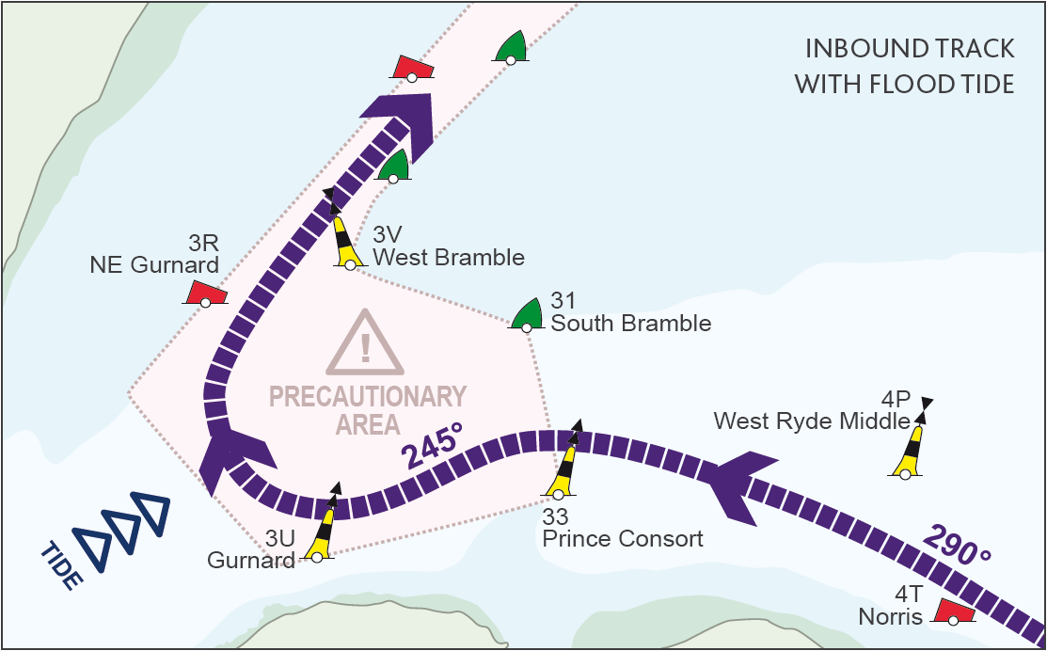
Figure 2 - Inbound Track with a Flood Tide

If the tide is flooding, this will set an inbound ship to the east as it turns into the Thorn Channel. As it approaches The Precautionary Area, in vicinity of the Prince Consort Buoy, the ship will make a substantial alteration to port, of up to 40 degrees to the southwest towards Gurnard Buoy, in order to give the maximum turning area into the Thorn Channel. The turn to starboard may not be commenced until the ship is very close to or just passed Gurnard Buoy, thus allowing some set to the east in the approach to the Thorn Channel entrance (See Figure 2).

In flood tide conditions, Masters of small vessels are advised to closely monitor the bearing of a large vessel as it approaches The Precautionary Area and to allow for the alteration of course to port.
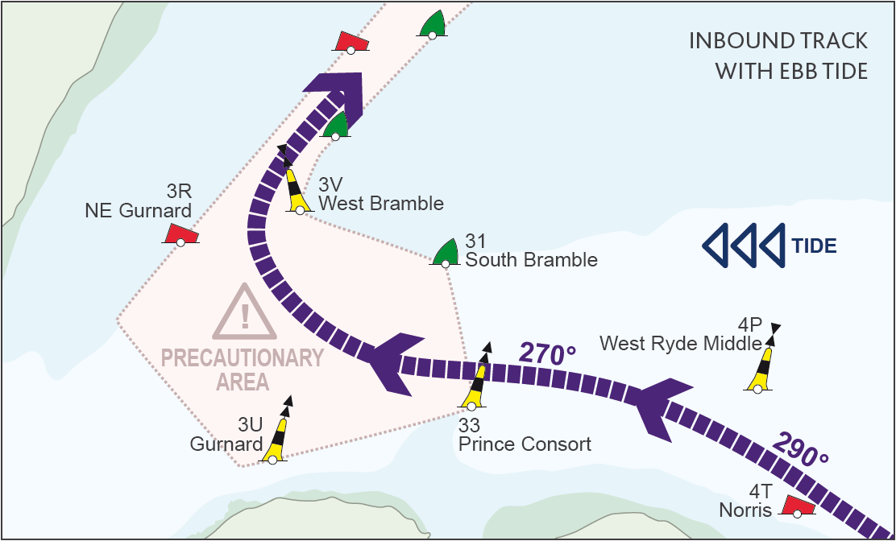
Figure 3 - Inbound Track with an Ebb Tide

If the tide is ebbing, the ship will be set to the west in the turn and thus the turn to starboard into The Thorn Channel will commence much earlier and as much as 4 – 5 cables from Gurnard Buoy. In this case, the alteration to port at Prince Consort Buoy may be less obvious (See Figure 3).

- Outbound vessel tracks

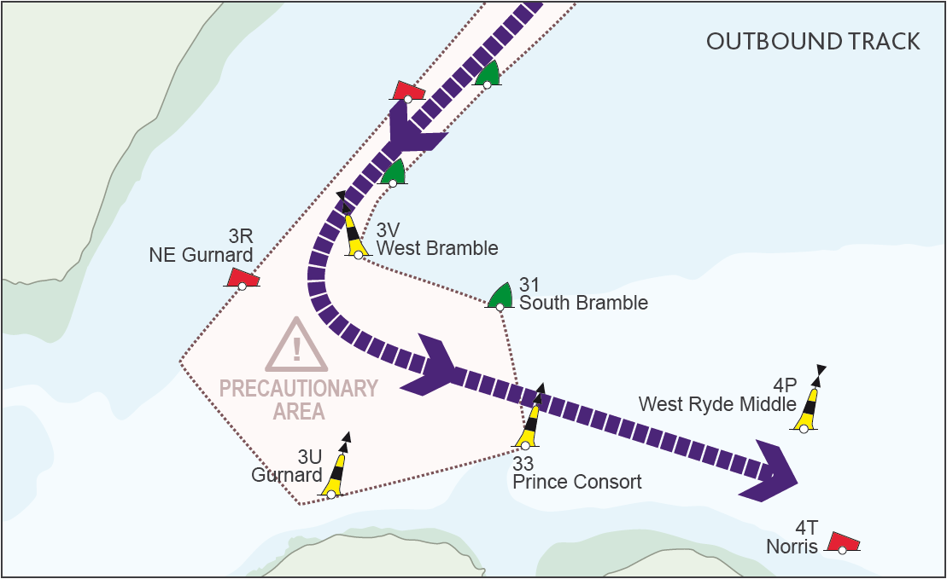
Figure 4 - Outbound Track with Flood or Ebb Tide

All ships leaving Southampton via the Thorn Channel start their turn to port as soon as West Bramble Buoy has been cleared, in order that on steadying up, their final heading is north of Prince Consort Buoy and directly towards the main channel south of Ryde Middle Bank. However, in ebb tide conditions the ship will be set to the west during the turn and may use the full extent of the south eastern quadrant of The Precautionary Area (See Figure 4).

- Southampton Harbour Master’s Patrol Launch

When operationally possible the Southampton Harbour Master’s Patrol Launch (VHF Call Sign ‘’SP’’ – listening watch VHF Channel 12) will precede vessels over 180 metres (150m length overall when leisure events are likely) length overall within ‘The Precautionary Area’ showing, in addition to the normal steaming lights, an all-round blue light. The absence of a patrol launch does not invalidate the implementation of a vessel’s MPZ.

Within The Precautionary Area all instructions given by the Southampton Harbour Master’s Patrol Launch should be acknowledged and promptly carried out.

- The content of this Notice will be kept under regular review, the content of which can also be found in The Leisure Guide to Southampton Water and its approaches and the Port Users Navigation Guidelines – both of which can be found at www.southamptonvts.co.uk.

Steven Masters,
Harbour Master

