Number 020 of 2026 | 01/01/2026

Wreck Piles – River Itchen

NOTICE IS HEREBY GIVEN that mariners are to be advised that a red, port-hand pile has been removed from the River Itchen, North of the Northam Bridge, referred to as Wreck #1 on Admiralty Charts and as pictured below.

Chartered Position - 50° 55’ 13.13”N, 001° 23’ 07.58”W.

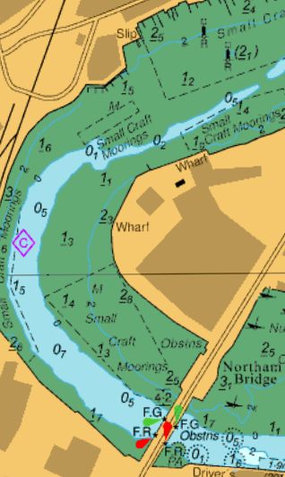
Mariners are also advised that Wreck pile #2, to the Southeast of Wreck pile #1, is still on station and has been replaced, with a brand-new pile pictured below.
Wreck pile #1 removed

Chartered position - 50° 55’ 11.86”N, 001° 23’ 05.51”W.
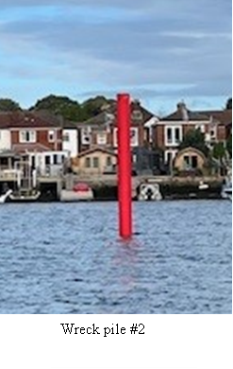

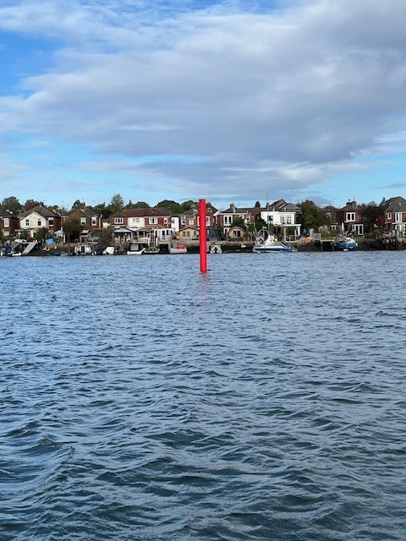
Wreck pile #2
Steven Masters,
Harbour Master

