Number 37(T) of 2026 | 13/02/2026

Installation of Light on Private Mooring Buoy Near Esso Terminals

NOTICE IS HEREBY GIVEN that the unlit yellow private mooring buoy for Southampton Partol Launches located southeast of the Esso terminals, will now have a light installed to ensure visibility.

The mooring buoy, highlighted on the Chartlet below, will have a light characteristic Fl.Y 4s (A short yellow flash once every 4 seconds).

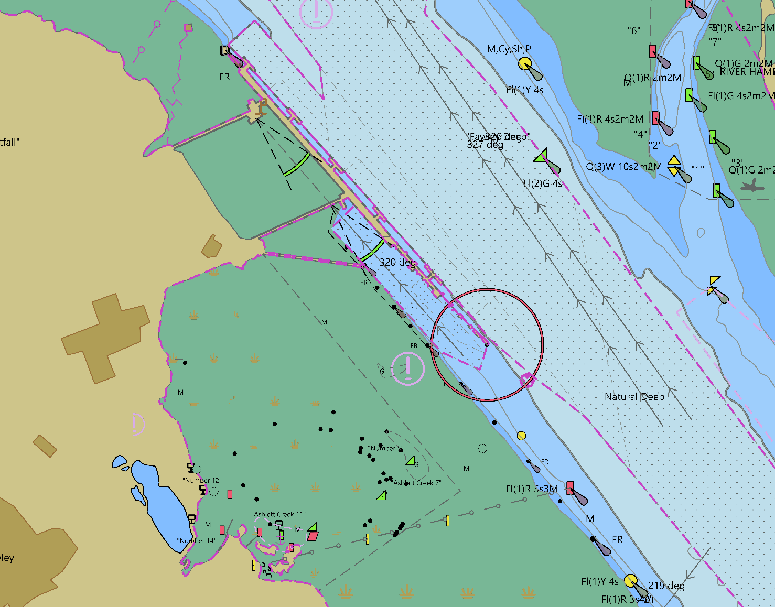

This notice will be self-canceling once the UK Hydrographic Office have updated digital charts.

Steven Masters,
Harbour Master

