Number 15 of 2026 | 01/01/2026

Port of Southampton – Restricted Zones

NOTICE IS HEREBY GIVEN that four restricted zones for the purpose of Part III of the Aviation and Maritime Security Act 1990 are now in place within Southampton Water. These areas include the Esso Refinery at Fawley, BP Hamble, and all berths within the Western and Eastern docks. These restricted zones are in place indefinitely.

Restriction Zone 1:

The restricted zone means an area around Esso Fawley as defined in the provided map with coordinates identified as:

FW1 (Origin Latitude 50.84383189. Origin Longitude -1.337542251)
FW2 (Origin Latitude 50.84549919. Origin Longitude -1.334403139)
FW3 (Origin Latitude 50.83352267. Origin Longitude -1.318420725)
FW4 (Origin Latitude 50.8315275. Origin Longitude -1.322167386)

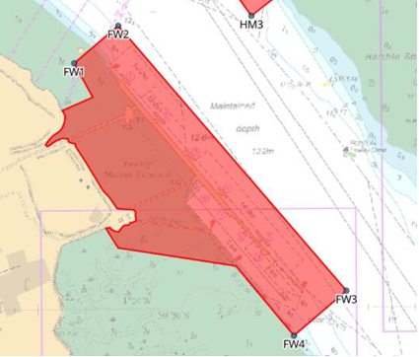

Restricted Zone 2:

The restricted zone means an area around BP Hamble as defined in the provided map with coordinates identified as:

HM1 (Origin Latitude 50.85105689. Origin Longitude -1.327028426)
HM2 (Origin Latitude 50.84972052. Origin Longitude -1.329247305)
HM3 (Origin Latitude 50.84588637. Origin Longitude -1.324971604)
HM4 (Origin Latitude 50.84742882. Origin Longitude -1.321820014)
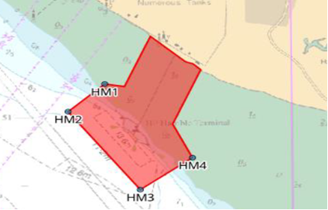

Restricted Zone 3:

The restricted zone means an area around ABP Western Docks as defined in the provided map with coordinates identified as:

WD1 (Origin Latitude 50.91046351. Origin Longitude -1.467215256)
WD2 (Origin Latitude 50.90968772. Origin Longitude -1.466729859)
WD3 (Origin Latitude 50.9024337. Origin Longitude -1.450098283)
WD4 (Origin Latitude 50.9021136. Origin Longitude -1.444659942)
WD5 (Origin Latitude 50.90610832. Origin Longitude -1.440770207)
WD6 (Origin Latitude 50.90634231. Origin Longitude -1.43800075)
WD7 (Origin Latitude 50.89711452. Origin Longitude -1.410178102)

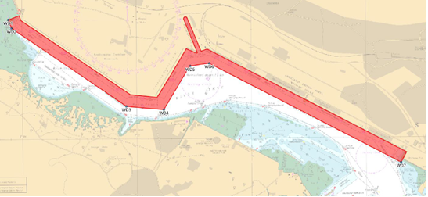

Restricted Zone 4:

The restricted zone means an area around ABP Eastern Docks as defined in the provided map with coordinates identified as:

ED1 (Origin Latitude 50.88954757. Origin Longitude -1.40109393)
ED2 (Origin Latitude 50.88683545. Origin Longitude -1.399232262)
ED3 (Origin Latitude 50.88656072. Origin Longitude -1.398386421)
ED4 (Origin Latitude 50.881507. Origin Longitude -1.394915583)
ED5 (Origin Latitude 50.88140055. Origin Longitude -1.390237635)
ED6 (Origin Latitude 50.88705883. Origin Longitude -1.389702107)
ED7 (Origin Latitude 50.89211371. Origin Longitude -1.386800245)

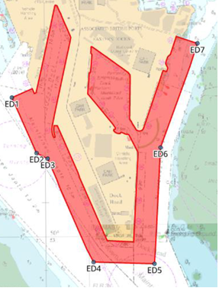

All craft may still transit through these areas (at best possible safe speed), subject to the avoidance of shipping movements and compliance with existing bylaws, but craft must not at any time loiter in these restricted zones.

These restricted zones give the Police the powers to arrest any person that fails to leave the areas defined when asked to do so by Southampton Harbour Master, Southampton VTS, Southampton Patrol, Marine Police Unit or any other authorised person.

Steven Masters,
Harbour Master

