Number 36(T) of 2026 | 04/02/2026

Southampton Patrol Survey Operations

NOTICE IS HEREBY GIVEN that mariners are to be advised that ‘SP SPITFIRE’ is to be used as a survey vessel until further notice.

‘SP SPITFIRE’ will be operating throughout the port limits and will be surveying at slow speeds of around 6 knots.

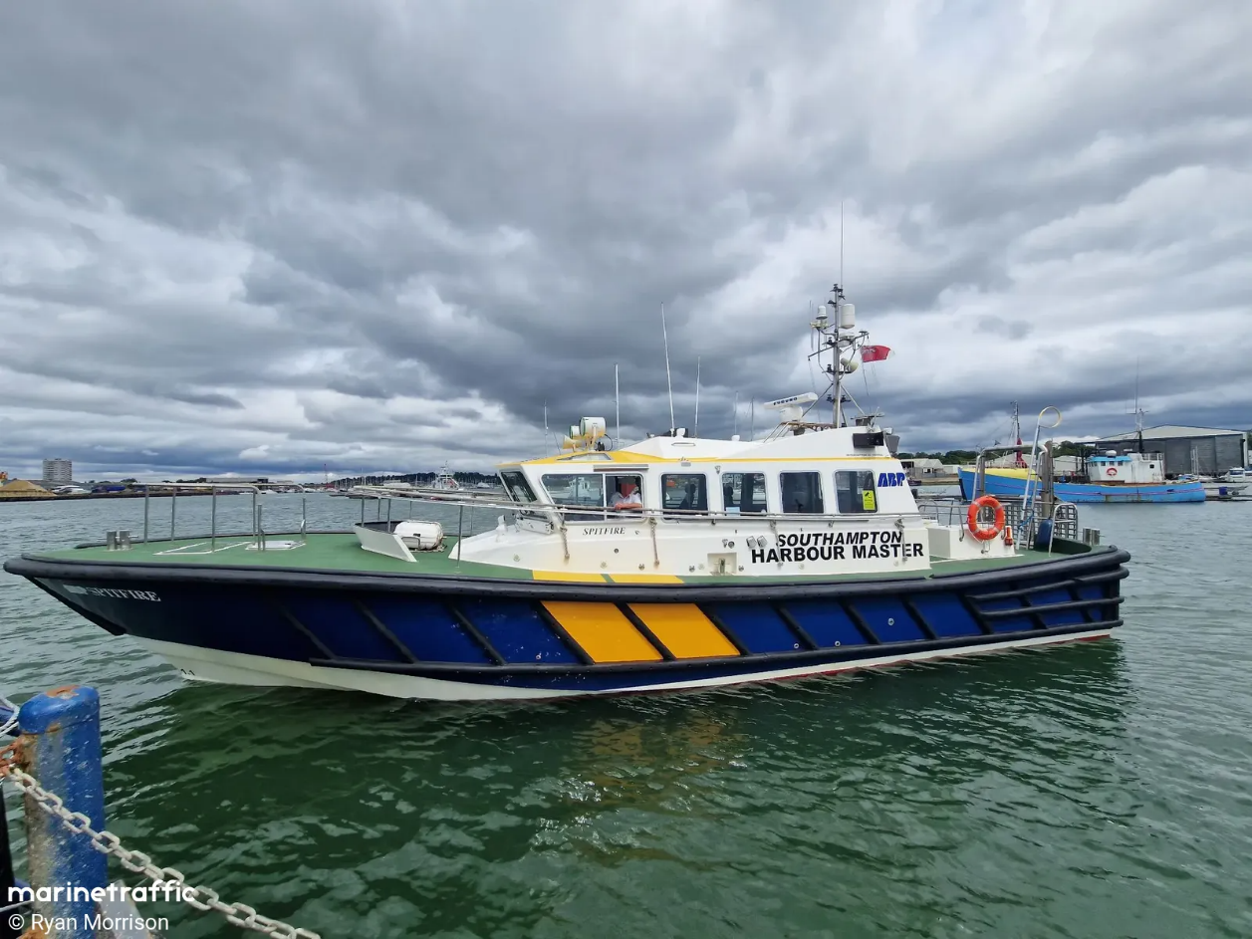
Figure 1: SP SPITFIRE being utilized as a survey vessel.

Vessels will display lights and shapes as required by the COLREGS and will maintain a listening watch on VHF Channel 12. Mariners are advised to keep clear as safe navigation permits, passing at slow speed and minimum wash. Additional information can be requested from “Southampton VTS” on Channel 12.

This notice will be self-canceling on completion.

Steven Masters,
Harbour Master

