Number 04 of 2026 | 01/01/2026

Port of Southampton – Pilot Boarding and Disembarking Arrangements – Non-compliant, Counterfeit, or Defective Pilot Ladders

NOTICE IS HEREBY GIVEN that some ships have presented with a pilot transfer arrangement consisting of an accommodation ladder / pilot ladder combination with a trapdoor that does not meet IMO standards (which have been in effect since at least 2012). Southampton Pilots have been reminded that they must refuse to use a pilot transfer arrangement that they reasonably believe is unsafe. Any vessels with a trapdoor arrangement are urged to bring their arrangements into compliance with the current IMO standards as soon as possible in order to avoid potential disruptions to ship schedules and port operations.

The relevant documents are SOLAS V Regulation 23, IMO Resolution A. 1045 (27) and guidance from The Embarkation & Disembarkation of Pilots Code of Safe Practice.

The arrangements in Figure 1 and Figure 2 (below) are non-compliant because:

- The pilot ladder is not rigged to extend through the trapdoor and secured 1½ metres above the bottom platform (SOLAS 3.3.2.1). The method of securing the ladder to the underside of the platform shown in the figure is dangerous because the transition from the pilot ladder is done via an uneven step height.

- The horizontal cross member to which the pilot ladder is secured is a distraction from using the side ropes when transitioning onto the pilot ladder when disembarking.

- The pilot ladder steps cannot rest firmly against the ship's side, due to the nylon wheels attached on the inboard side of the bottom platform.

- The ‘accommodation ladder’ is not securely attached to the hull.

Figure 3 (below) shows a compliant boarding arrangement. Further guidance is available in “Shipping Industry Guidance on Pilot Transfer Arrangements, Ensuring Compliance with SOLAS” to be found at www.ics-shipping.org.
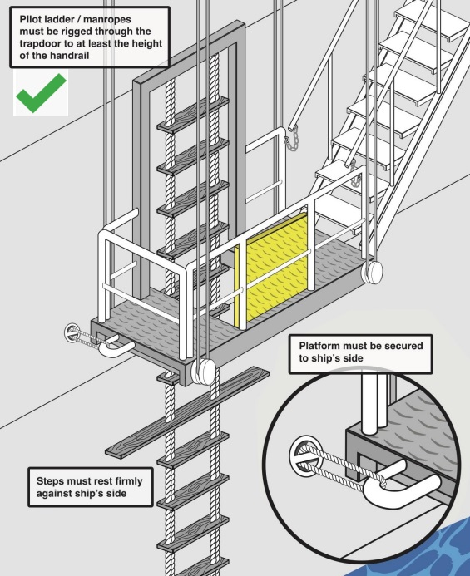
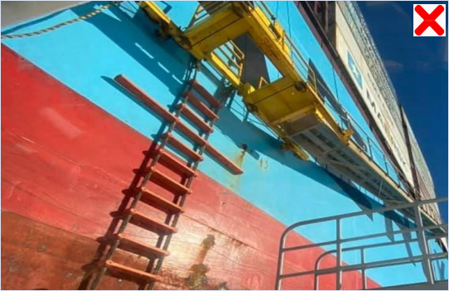

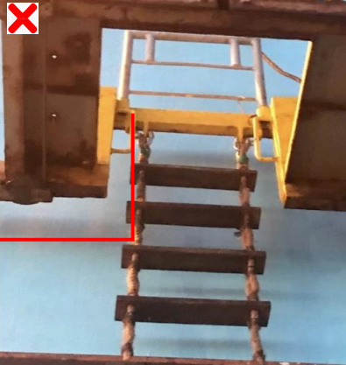
Figure 1 - Non-Compliant Trap Door Arrangement
Figure 2 - Non-Compliant Trap Door Arrangement
Figure 3 - Compliant Trap Door Arranagement

Vessels presenting themselves with unsafe or non-compliant pilot boarding arrangements, which do not meet the requirements set out in SOLAS V regulation 23 and IMO Resolution A.1045 (27), will be refused boarding and will be instructed to rectify the non-conformity, go to anchor or will be refused entry into the port. This can cause lengthy delays and may incur additional charges.

It is the responsibility of each person involved in the activity of pilot transfers, including ship owners, masters and crew, pilots and pilot boat crew, as well as the CHA to ensure safe practices.

The Harbour Master and Associated British Ports give their full support to pilots refusing to board non-compliant vessels. Defective and non-compliant arrangements reported by pilots are shared with the MAIB, the local MCA marine office and the United Kingdom Marine Pilot’s Association.

It has recently come to the attention of ABP Southampton that some vessels are in possession of counterfeit pilot ladders that are not compliant with ISO standards. The current legislation is that pilot ladders MUST comply to ISO799-1, and their certificate and certification plate must display this.

Counterfeit ladders displaying compliance to ISO779-1 have been identified. These are non-compliant and will be refused by ABP Southampton Pilots.

Figure 4 shows a non-compliant certification plate because it references approval ISO779-1.

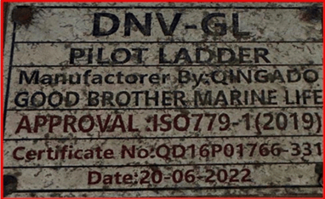

Figure 5 shows a compliant certification plate because it is referencing approval ISO799-1.

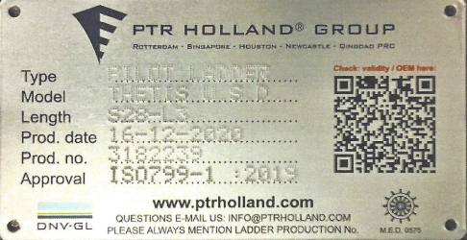

Where non-compliant ladders are discovered, this will be reported to Port State Control and further inspections may be carried out.

The key focus points are:

- Stanchions must be in place.
- Pilot ladder rope to be in good repair.
- Pilot ladders must not be secured using deck tongues.
- Pilot ladders must not be secured from the deckhead.
- Pilot ladders must not be secured from, or over handrails.
- Winnets or chocks should not be loose or slack.
- Steps to be in good repair, neither painted nor varnished.
- The rigging of the pilot ladder must be checked, and the embarkation and/or disembarkation of the pilot must be supervised by a responsible officer.
- A tripping line when used shall fitted to the bottom of the ladder, and must be rigged in accordance with IMO Resolution A.1045(27) 2.1.5.
- The pilot embarkation point on the deck must be free from obstructions and adequately lit.
- All ladders must be constructed and rigged as per SOLAS regulations and certificated to comply to ISO799-1.

Pilots are encouraged to deliver the ABP pilot safety poster onboard (Figure 6).

Steven Masters,
Harbour Master
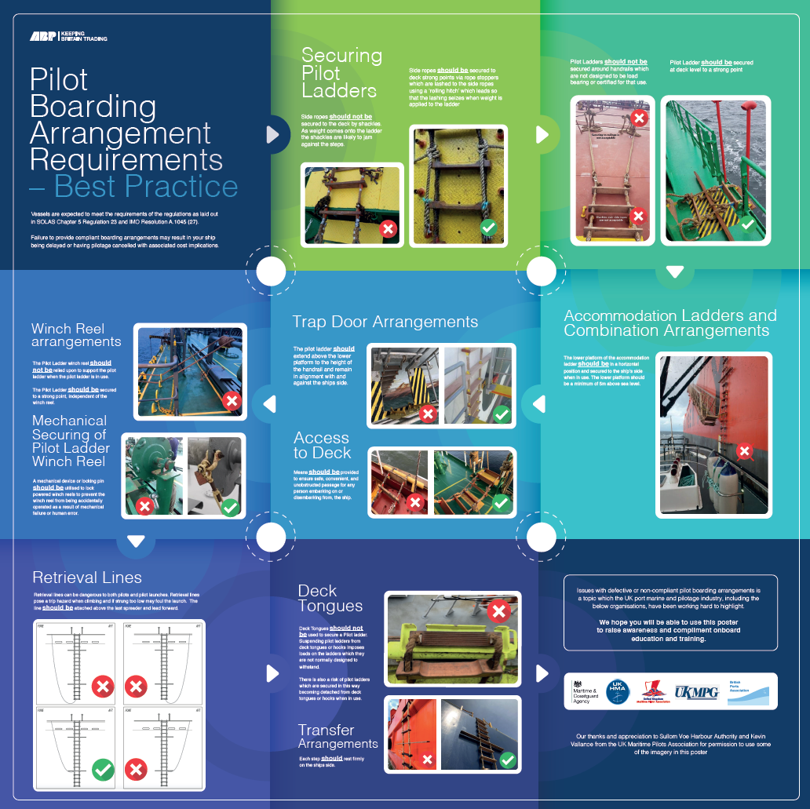
Figure 6 - ABP Pilot Boarding Arrangement Requirements - Best Practice

