Number 38(T) of 2026 | 16/02/2026

Discontinue Special Marks at Marchwood

NOTICE IS HEREBY GIVEN that three special marks (yellow fixed posts fitted with an “X” topmark) located within the Marchwood Moorings area have been permanently removed and are no longer in service.

The positions of the discontinued marks are shown highlighted in red on the chartlet below.

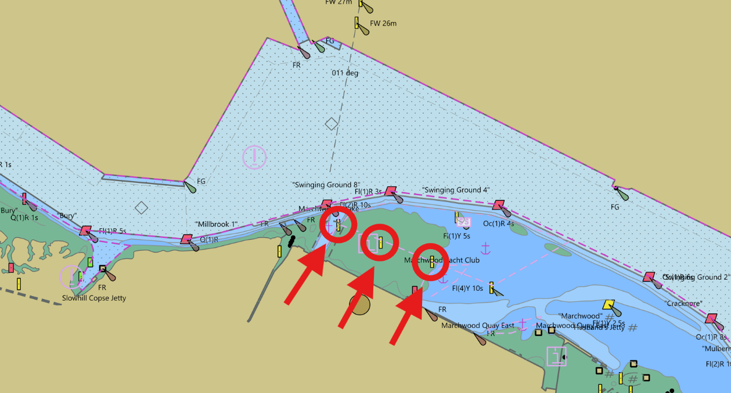

This notice will be self-canceling once the UK Hydrographic Office have updated the nautical charts.

Steven Masters,
Harbour Master

