Number 41(T) of 2026 | 10/03/2026

Temporary Removal of NAB Wave Buoy (Amended)

NOTICE IS HEREBY GIVEN that mariners are to be advised that the NAB wave buoy is planned to be temporarily removed on Monday 2nd March and reinstated on Friday 6th March. Friday 27th March

During this period the buoy will not be on station and no wave data will be available from this location. The temporary removal is required to allow maintenance and inspections to take place.

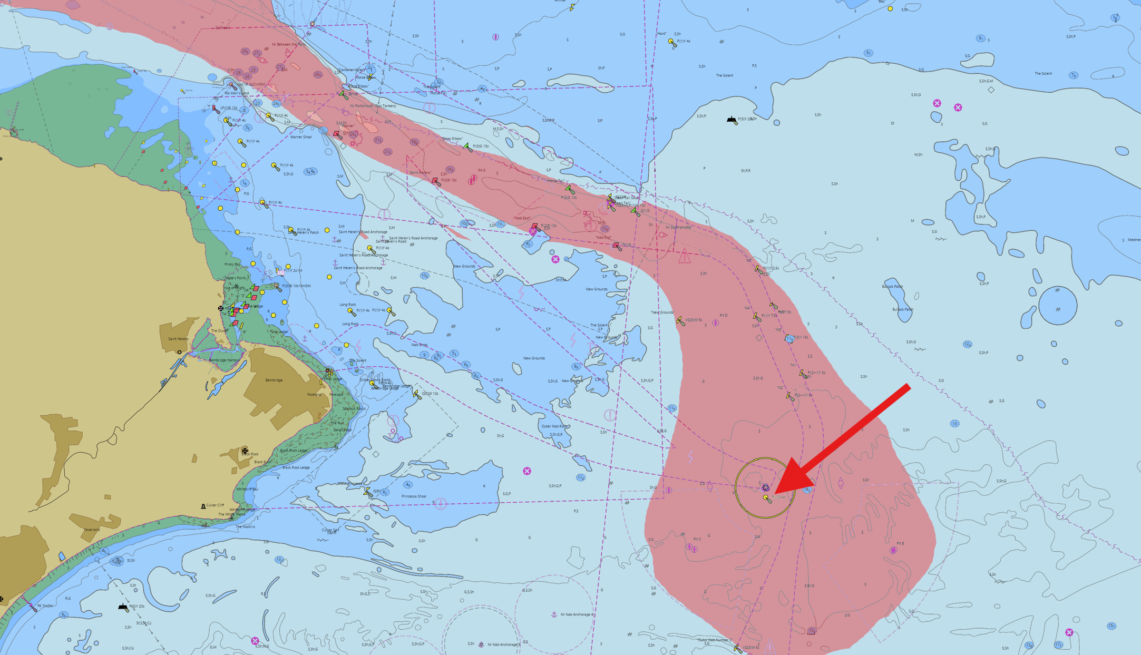

This notice will be self-canceling on completion.

Steven Masters,
Harbour Master

